

**PROJECT REPORT**

**DEPARTMENT OF ELECTRICAL, ELECTRONIC AND COMMUNICATION ENGINEERING**

**COURSE CODE: EECE-212**

**PROJECT RRPORT OF GROUP 7**

**PROJECT NAME: Data Analysis Using MATLAB**

**Faculty Members**

* Lt Col Hussain Md Abu Nyeem
* Maj Marzuka Ahmed Jumana
* Lec Nazifa Nawar
* Lec Tareque Bashar Ovi

**By: SECTION- B**

|  |  |
| --- | --- |
| **Name** | **ID** |
| Osama Ahmed Ibrahim | 202316126 |
| Hafsa Khan | 202316105 |
| Md. Mahfuzur Rahman Kabbo | 202316071 |
| Md. Jiman | 202316101 |

**Table Of Contents:**

|  |  |
| --- | --- |
| **Title** | **Page Number** |
| **i. Objectives** | **03** |
| **ii. Introduction** | **04** |
| **iii. Methodology** | **05** |
| **iv. Algorithm** | **06** |
| **v. Simulation** | **11** |
| **vi. Graph** | **12** |
| **vii. Results** | **13** |
| **viii. Conclusion** | **15** |
| **ix. Appendix** | **16** |

**Objectives:**

* **Visualize Pricing Data**: Create meaningful visualizations (scatter plots, bar charts) to display actual, predicted, and relative price changes between iPhone models.
* **Enhance Data Interpretation**: Utilize the model and visualizations to better understand the pricing strategy of Apple and market dynamics.
* **Analyze iPhone Pricing Trends**: Investigate how the prices of iPhone models have evolved over time and identify any patterns or trends.
* **Develop a Predictive Model**: Build a linear regression model to predict the price of a new iPhone model based on historical data.
* **Evaluate Price Changes**: Calculate and visualize the differences in prices between consecutive iPhone models and the percentage changes over time.
* **Provide Price Forecasting**: Offer predictions for future iPhone models’ prices, allowing for informed decision-making.

**Introduction**

Linear regression is a widely used statistical technique for understanding the relationship between a dependent variable and one or more independent variables. In this context, the dependent variable is the price of iPhone models, while the independent variable is the version of the iPhone. Linear regression operates under the assumption that there is a linear relationship between the two variables, meaning that changes in the independent variable (iPhone versions) will cause proportional changes in the dependent variable (iPhone price). This method estimates a line of best fit through the data points that minimizes the difference between the actual prices and the predicted prices, which is crucial for forecasting future trends.

The primary goal of this project is to apply a linear regression model to a dataset containing iPhone models and their respective prices to predict the price of a new iPhone model. The process begins with loading a dataset, where the model versions and corresponding prices are extracted as independent and dependent variables, respectively. Using these variables, a linear regression model is fitted to analyze the historical pricing patterns of the iPhone models.

Once the model is fitted, it allows us to make predictions about the price of future iPhone models. In this particular code, the user inputs the version of a new iPhone model, and the model generates a predicted price based on the linear trend derived from previous data. This prediction can offer insights into how the price may change, depending on factors like new features or technological improvements in future models.

In addition to predicting prices, the code calculates price differences between consecutive models to highlight the fluctuations between each generation of iPhone. This analysis helps understand whether there has been a consistent upward or downward trend in pricing, or if certain models have experienced larger price jumps than others. Furthermore, the percentage change in price between consecutive models is computed to give a clearer picture of the rate at which prices are increasing or decreasing.

Visualization plays a key role in interpreting the results of this analysis. The code creates a scatter plot that shows actual prices of iPhones and overlays the regression line to indicate the overall trend. Additionally, it provides a bar chart depicting the differences in price between consecutive models, allowing users to quickly spot significant changes.

A final bar chart displays the percentage change in price, offering insights into the relative size of price adjustments from one model to the next. Together, these methods provide a thorough understanding of how iPhone prices have evolved and allow users to predict future pricing strategies. This analysis can help Apple and other businesses anticipate customer reactions to new pricing models and aid consumers in making more informed purchasing decisions.

**Methodology**

The methodology of this project follows these steps:

1. **Data Collection**: A dataset containing the versions of iPhones and their respective prices was collected.
2. **Data Preprocessing**: The dataset was read and stored in a table format in MATLAB, with separate columns for the iPhone versions and prices.
3. **Model Development**: A linear regression model was fitted to predict the prices of iPhone models based on their version numbers.
4. **Prediction**: The model was used to predict the price of a new iPhone model based on its version number.
5. **Price Analysis**: The differences in prices between consecutive models were calculated to evaluate the trend and the percentage change in pricing.
6. **Visualization**: Three different plots were created to visualize the price trends, price differences, and the percentage changes in prices between iPhone models.

**Algorithm**

* **Loading the Dataset**

|  |
| --- |
|  |

* This line reads the CSV file located at **'D:\Matlab Project\Project 2\iphone_price.csv'** and stores it as a table in the variable **data**.
* **Extracting Variables**

|  |
| --- |
|  |

* Here, the variables **version** and **price** are extracted from the **data** table. **X** holds the iPhone model versions, and **y** holds their corresponding prices.
* **Fitting a Linear Regression Model**

|  |
| --- |
|  |

* A linear regression model is fitted using the **fitlm** function with **X** as the independent variable and **y** as the dependent variable. The fitted model is stored in the variable **model**.
* **Predicting the Price for a New iPhone Model**

|  |
| --- |
|  |

* The code prompts the user to enter a value for the new iPhone model version (**newModel**).
* The price for this new model is predicted using the **predict** function with the fitted **model** and the entered **newModel**.
* **Displaying the Predicted Price**

|  |
| --- |
|  |

* The predicted price is printed to the console with a formatted string. **%d** is used for the integer **newModel** and **%.2f** is used for the floating-point **predictedPrice** with two decimal places.
* **Calculating Price Differences and Percentage Changes**

|  |
| --- |
|  |

* **priceDifferences** is calculated as the difference between successive prices using the **diff** function.
* **percentageChange** is calculated as the percentage change in prices between successive models. This is done by dividing **priceDifferences** by the corresponding previous prices (**y(1:end-1)**) and multiplying by 100.
* **Plotting the Data**

|  |
| --- |
|  |

* A new figure window is created to plot the charts.
* **Subplot 1: Data and Regression Line**

|  |
| --- |
|  |

* A subplot is created in the first row (**subplot(3,1,1)**).
* The **hold on** command allows multiple plots in the same axes.
* A scatter plot of the actual prices (**X** vs. **y**) is created with blue filled circles.
* The regression line (fitted model) is plotted in red.
* The predicted price for the new model is plotted as a green circle.
* Labels for the x-axis and y-axis, a title, and a legend are added to the plot.
* The **hold off** command releases the plot hold.
* **Subplot 2: Price Differences**

|  |
| --- |
|  |

* A subplot is created in the second row (**subplot(3,1,2)**).
* A bar chart of price differences between successive iPhone models is plotted.
* Labels for the x-axis and y-axis, a title, and grid lines are added to the plot.
* **Subplot 3: Percentage Change in Prices**

|  |
| --- |
|  |

* A subplot is created in the third row (**subplot(3,1,3)**).
* A bar chart of percentage changes in prices between successive iPhone models is plotted.
* Labels for the x-axis and y-axis, a title, and grid lines are added to the plot.

**Simulation**

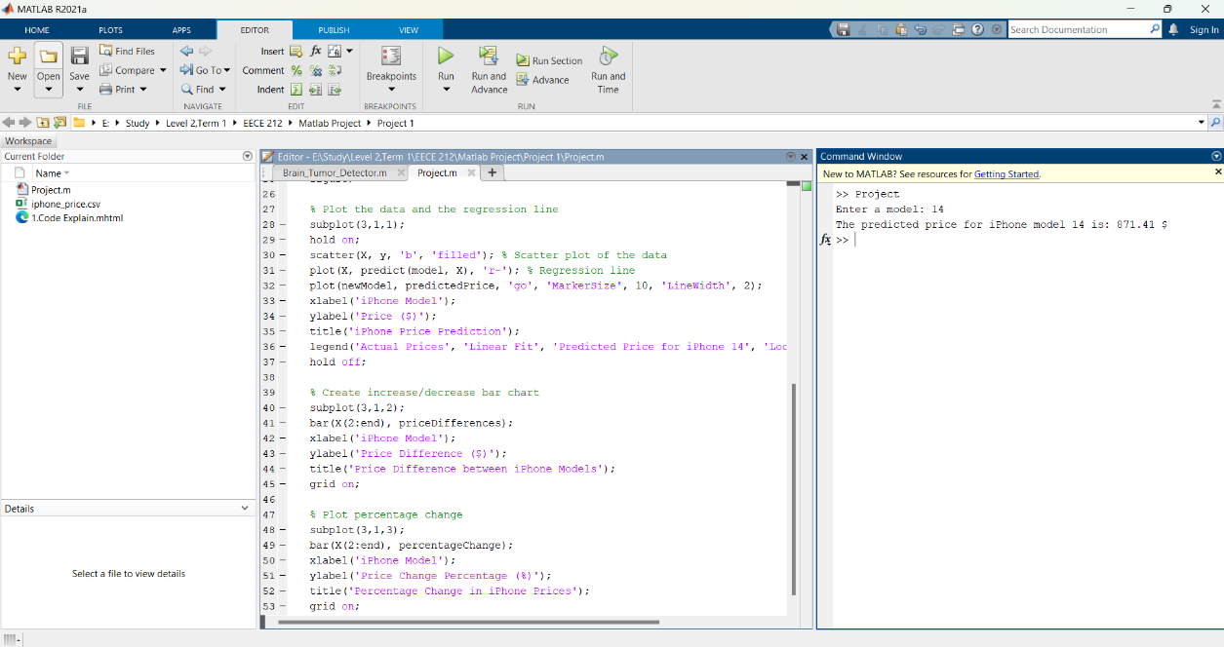

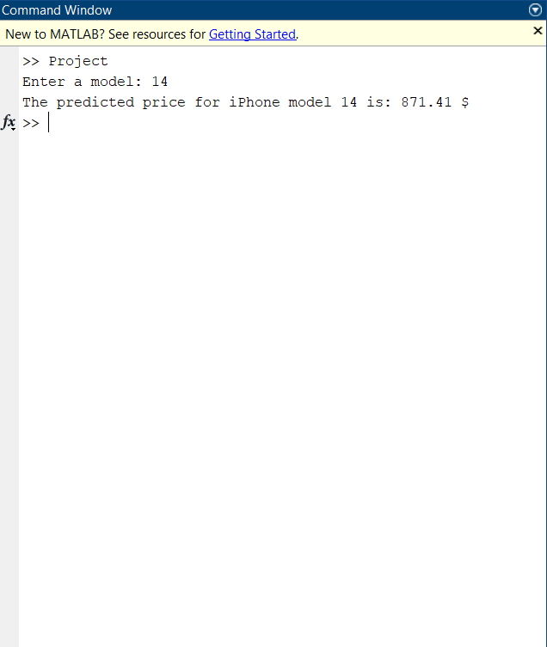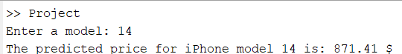

**Graph**

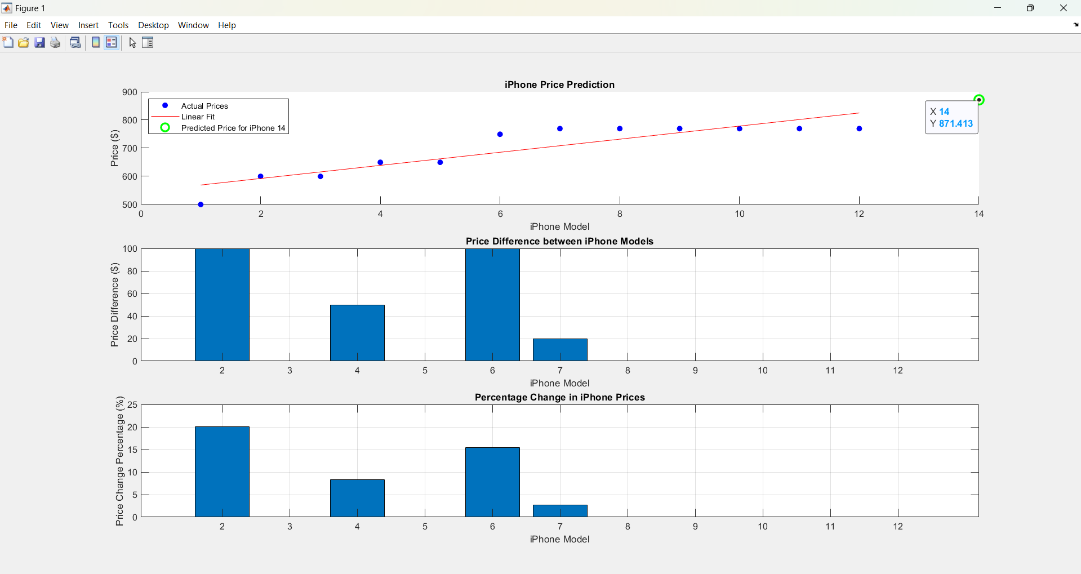

**Results**

After fitting the linear regression model and visualizing the data:

* The **scatter plot** with the linear regression line shows how well the linear model fits the price trend.
* The **bar chart** of price differences illustrates how the price changes between consecutive iPhone models. Some models have a significant price increase compared to others, indicating trends in innovation or market pricing strategies.
* The **percentage change** chart highlights the relative change in pricing, which helps in understanding the pricing strategy for newer models.

Additionally, a new iPhone model's predicted price is displayed based on user input.

**Future Scope:**

* **Advanced Predictive Models**: Extend the project by using more sophisticated machine learning techniques such as **polynomial regression**, **support vector machines** , or **neural networks** to capture nonlinear relationships between iPhone versions and their prices for improved accuracy in predictions.
* **Incorporating Additional Features**: Future models can incorporate more variables beyond the iPhone version, such as **release date**, **storage capacity**, **technological advancements**, and **market trends**, to enhance the model's predictive capabilities.
* **Dynamic Price Prediction**: Integrating real-time data from the market, including promotions, seasonal sales, or global economic factors, could make the price predictions more adaptable and reflective of current market conditions.
* **Time Series Analysis**: Adding a time-series analysis component can provide insights into how iPhone prices fluctuate over time and forecast long-term trends, especially considering inflation and global demand.
* **Global Price Comparisons**: Expanding the scope by analyzing iPhone prices in different countries could reveal regional pricing strategies and help predict prices for various markets.
* **Automated Data Collection**: Using web scraping techniques or APIs to automatically update the dataset with new iPhone models and prices can make the project dynamic, offering predictions for every upcoming iPhone model release.

**Conclusion**

The project successfully demonstrated the use of linear regression for predicting iPhone prices based on historical data. The model can be used to forecast future prices, offering insights into price patterns over time. The visualizations provide a clear understanding of how prices evolve between iPhone models. However, the model assumes that the relationship between iPhone versions and prices is linear, which may not always be the case in real-world scenarios. Future work could explore more complex models for improved accuracy.

**Appendix**

**Code:**

% Load the dataset

data = readtable('D:\Matlab Project\Project 1\iphone_price.csv');

% Extract the variables

X = data.version;

y = data.price;

% Fit a linear regression model

model = fitlm(X, y);

% Predict the price for iPhone newModel

newModel = input('Enter a model: ');

predictedPrice = predict(model, newModel);

% Display the predicted price

fprintf('The predicted price for iPhone model %d is: %.2f $\n', newModel,predictedPrice);

% Calculate the price differences

priceDifferences = diff(y);

% Calculate percentage change in prices

percentageChange = priceDifferences ./ y(1:end-1) * 100;

% Plot all charts in one figure

figure;

% Plot the data and the regression line

subplot(3,1,1);

hold on;

scatter(X, y, 'b', 'filled'); % Scatter plot of the data

plot(X, predict(model, X), 'r-'); % Regression line

plot(newModel, predictedPrice, 'go', 'MarkerSize', 10, 'LineWidth', 2);

xlabel('iPhone Model');

ylabel('Price ($)');

title('iPhone Price Prediction');

legend('Actual Prices', 'Linear Fit', 'Predicted Price for iPhone 14', 'Location', 'NorthWest');

hold off;

% Create increase/decrease bar chart

subplot(3,1,2);

bar(X(2:end), priceDifferences);

xlabel('iPhone Model');

ylabel('Price Difference ($)');

title('Price Difference between iPhone Models');

grid on;

% Plot percentage change

subplot(3,1,3);

bar(X(2:end), percentageChange);

xlabel('iPhone Model');

ylabel('Price Change Percentage (%)');

title('Percentage Change in iPhone Prices');

grid on;